**MAKE PROJECT READONLY**

This tool is used for the purpose of removing users from all roles except for the Viewer role. The account needed to run the tool should be a TDAdmin to the projects you selected to run this tool. When being executed, the tool will first add the users to the Viewer group and then remove all the users from all roles. The user used to execute the tool will still remain in the TDAdmin group. You can remove him from all projects by deleting him from the instance at a later time. Ideally, you should have at least one admin in the projects for administrative purpose.

**Note: This tool is provided as is and HPE is not responsible for any potential issues. You should test it extensively first before deciding to use it.**

1. Install the TDConnectivity or Client Side Installation.

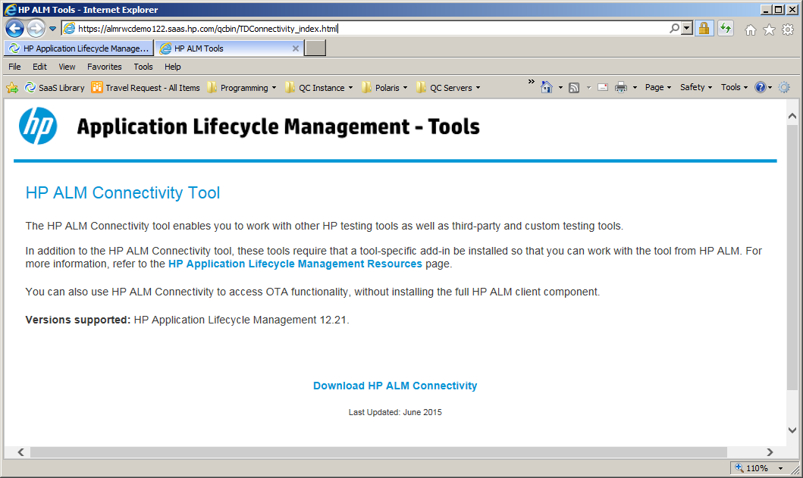

1. Create an excel file under c:\temp\saastoolkit and called it Readonly.xlsx. In the file, add the entry below:

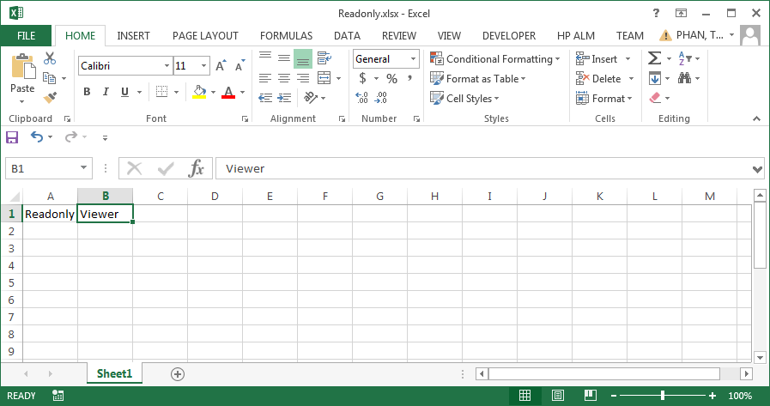

Note: If you want to use different role other than Viewer, then you need to replace it here.

1. Download the tool and click on the executable.

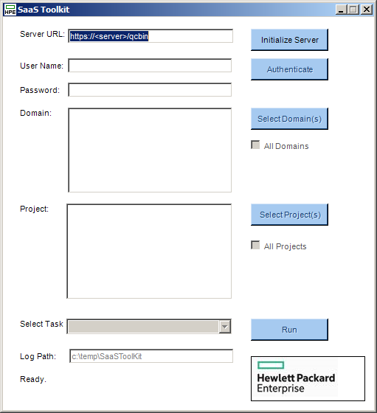

1. Enter the url and click on “Initialize Server” button.
2. Enter your user name and password. Click on “Authenticate” button.
3. Select your domain(s). Click on “Select Domain(s)” button.
4. Select your project(s). Click on “Select Project(s)” button.
5. Select the task “Move Users to Viewer Role”. Click On Run

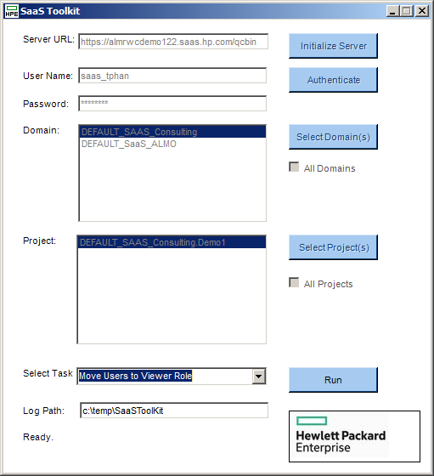

1. You should now see the dialog window below

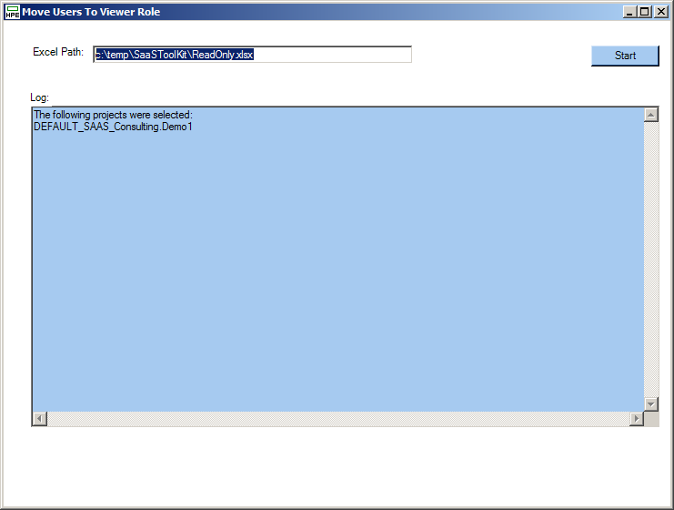

1. Click on Start button.
2. The tool will execute the action.

